JOB OPENING

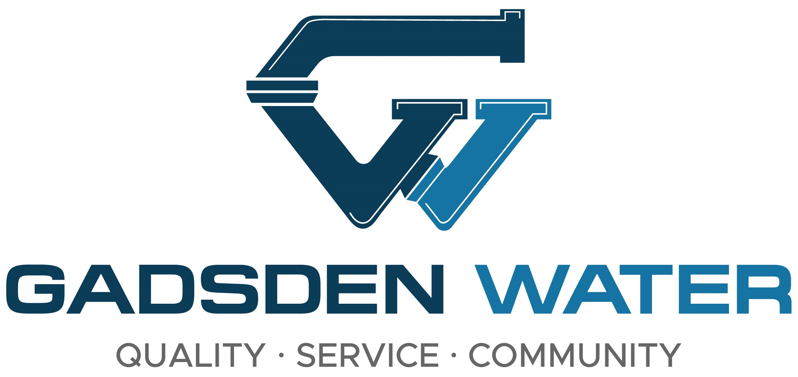

Wastewater Plant Operator

Gadsden Water Works is currently accepting applications for a Wastewater Treatment Plant Operator. Must possess and maintain Grade III or IV Wastewater Treatment Plant Operator Certification from ADEM and a valid Alabama Driver’s License. This is a full-time position with excellent benefits, including Blue Cross Blue Shield Insurance and State of Alabama Retirement. Salary range is $52,000 - $72,883 per year.

Apply at Gadsden Water Works, 515 Albert Rains Blvd., between the hours of 8:00-4:30 p.m. Monday through Friday, or by printing application at http://www.gadsdenwater.org and mailing to: Gadsden Water Works, Attn: Personnel Department, P.O. Box 800, Gadsden, AL 35902. Applications may also be emailed to jobs@gadsdenwater.org. Deadline for all applications will be Friday, March 14, 2025.

EQUAL EMPLOYMENT OPPORTUNITY STATEMENT

Gadsden Water Works does not discriminate on the basis of race, color, national origin, sex, religion, age and handicapped status in employment or the provision of service.

